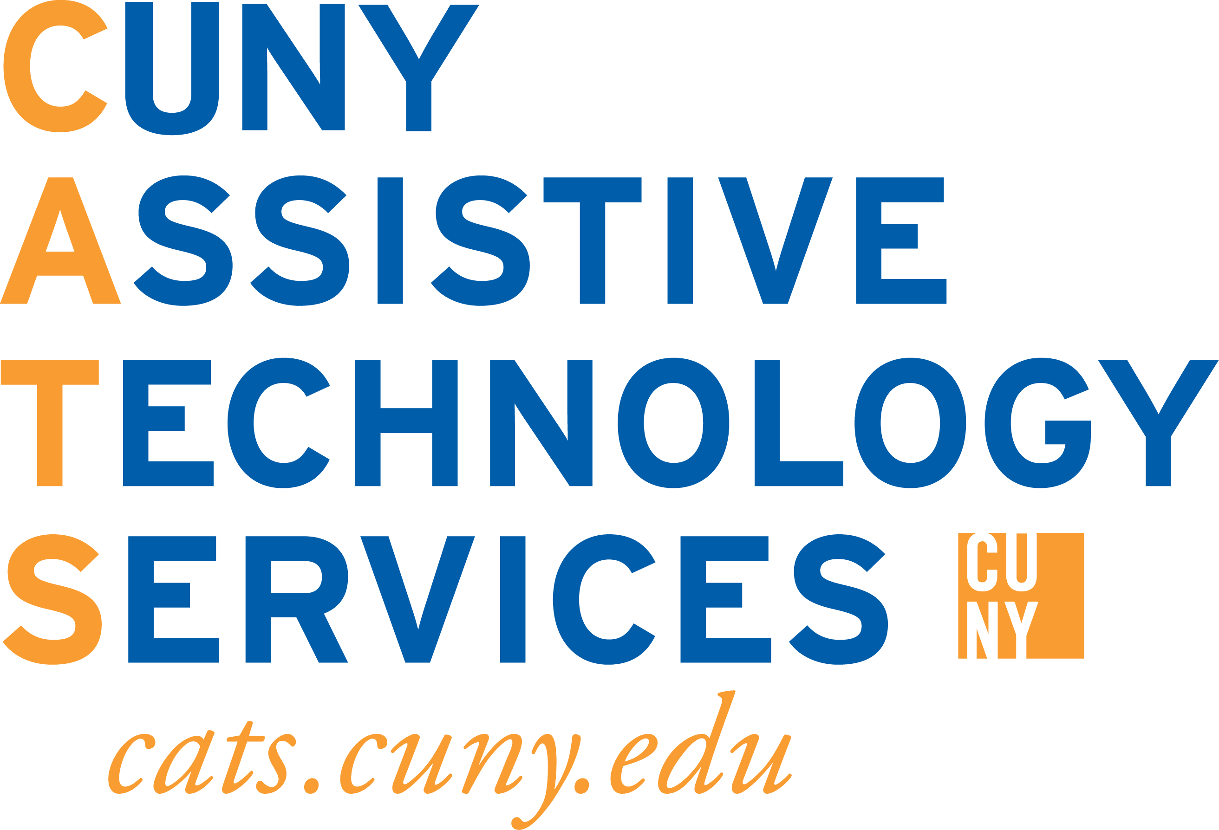
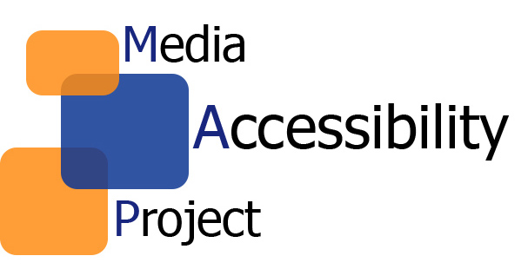

Best Practices on Course Accessibility

When: November 9th, 2016
12:00pm to 2:00pm
Where: Oakland Dining Hall

Light refreshments will be served

Are your lecture, online, or hybrid classes accessible to all students?

Join CUNY Assistive Technology Services (CATS) and the Media Accessibility Project (MAP) to learn how to create accessible course content using Microsoft Word and PowerPoint, PDFs, and audio/video content. There will also be an overview of the different types of Assistive Technology student’s use, such as Kurzweil 3000, Dragon Naturally Speaking, JAWS, and ZoomText.

Please register for the workshop here.

