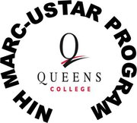
MAXIMIZING ACCESS TO RESEARCH CAREERS Fellowship
Interested in Research? You can make $1,008 a MONTH tax free!
Applications accepted immediately
Provides
- 2 years stipend : 60% tuition
- Laboratory research experience
- Funds to attend scientific conference
Eligibility
- Must attend QC and be a Junior in the Fall
- Minimum 3.0 GPA
- Must want to go to a PhD in biomedical sciences
- For racial minority or economically disadvantaged or students with disabilities
- U.S. citizen or permanent resident
**Contact MARC Office: Lynnmarie Alafnourian qc.marc@hotmail.com or NSB E-112 or (718) 570-0378**

Cut & paste URL into browser: http://www.qc.cuny.edu/Academics/Honors/MARC/Pages/default.aspx

DEADLINE FOR APPLICATIONS: March 14, 2016!!

