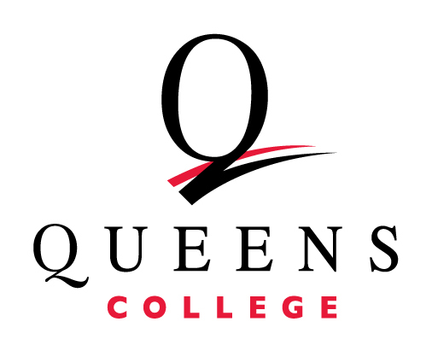
New Program for People with Parkinson’s
Do you know someone within the QC community with Parkinson’s who could benefit from low-to no-cost speech and communication therapy?
Though a grant from the Parkinson Voice Project, Queens College’s Speech-Language-Hearing-Center is excited to offer this new program for people with Parkinson’s disease to work on their speech and communications skills:

During SPEAK OUT!®, clients with Parkinson’s receive individual therapy and practice speaking with intent with a speech-language pathologist (SLP) through a series of speech, voice and cognitive exercises.

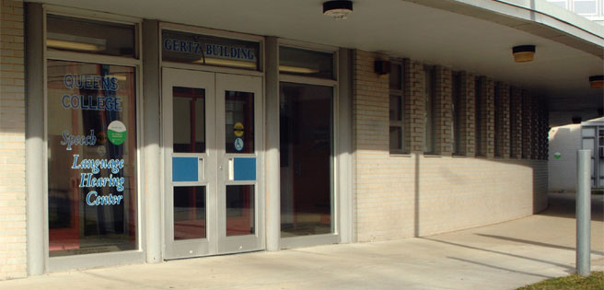
Upon completion, clients graduate to The LOUD Crowd® — weekly group sessions that reinforce the SPEAK OUT!® exercises and provide accountability, camaraderie, education, and support.

Family and friends of QC employees are also eligible for this new program. If you would like to learn more, please contact the Speech-Language-Hearing-Center at (718) 997-2946 or by email at speechcenter@qc.cuny.edu.

