SUPER SALE!!!
At The Queens College Bookstore!!!

Every Item with the Queens College Logo 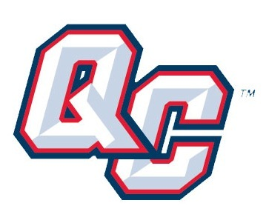

At the Bookstore is 50% off!!!
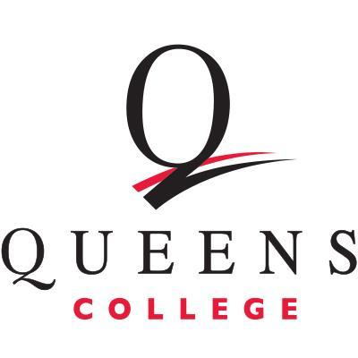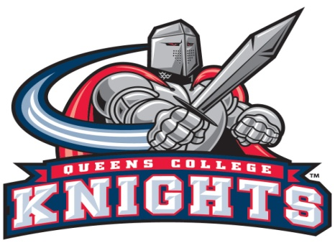
Shop Early For Best Selection!
See You There…!

All purchases are Final sale. While supplies last.

