Need a Math Tutor?

Call Today’s Tutors, Tomorrow’s Math Teachers
(718) 570-0520
or email mt4club@gmail.com
for a personal math tutor!
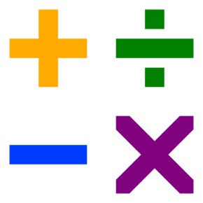

All tutors are mathematics secondary education majors at Queens College

Rates: $30/hour Remote Tutoring

The sooner you call, the sooner we can find a tutor for you.
Don’t wait until the week before your big exam.
Call Us Now!

Note: We are a part-time, student-run tutoring office. When you call, please leave a message with your information, including what level of tutoring you will need. We will call you back as soon as we can, but please be patient, as finding a tutor can sometimes take over a week.

For more information, visit time2000.qc.cuny.edu

