History 370-1: History and Film –
The Second World War Film
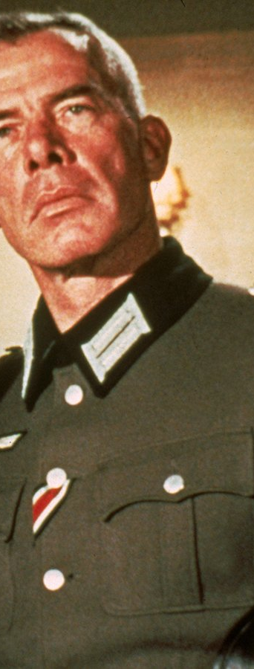
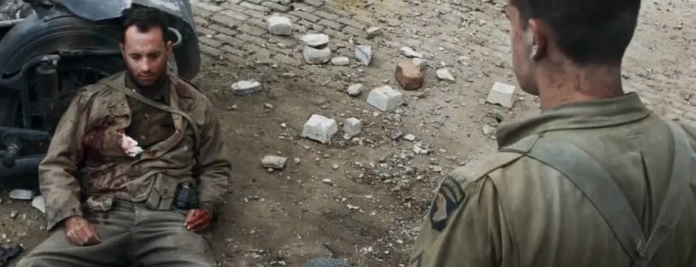
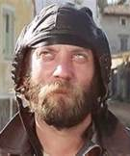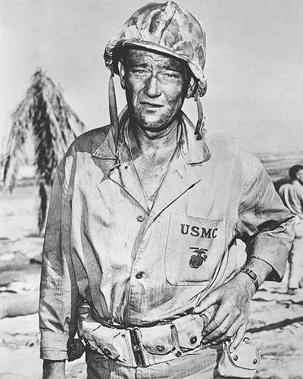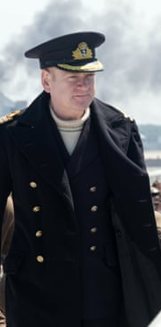
  - Professor Wintermute
  - Thursdays, 3:10pm to 6:00pm
Powdermaker Hall 157

Using a collection of critically acclaimed and popular films, dating from the 1940s to the current day, we will be examining the history and memory of the Second World War. Each week will be devoted to a specific topic, and will include a short topical lecture, a film screening, and a moderated discussion of the film’s historical context, contemporary and current meaning, and production. Don’t forget to bring your popcorn and Mike and Ike’s!

