History 163-3: Topics in US History –
Race, Gender, and Military History

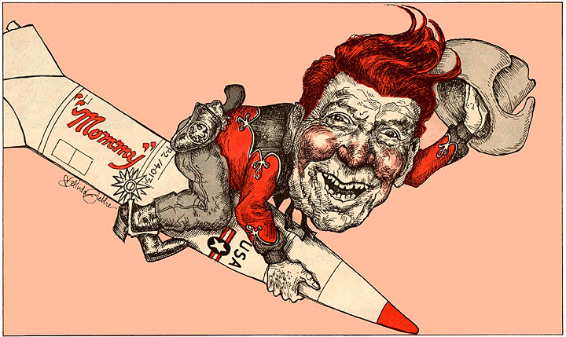
  - Professor Wintermute
  - Tuesdays, 6:30pm to 9:20pm
Powdermaker Hall 157

How do military institutions respond to social pressures and changes? How does war transform the context of gender, race, and ethnicity in civilian society? What are the pressures and challenges imposed by conflict on social constructed forms of personal and collective identity? Is violence in war inherently gendered? How do racial prejudices and perceptions translate into action on the field of battle? What is the future state of warfare in a world of fluid gender, racial, and ethnic identities? These questions and others are the foundation of this combined lecture and discussion weekly course.

