HISTORY 186 (42022)
Introduction to Legal History
From Cavemen to Citizens United
Fall 2016 ♦ Thurs 4:30-7:20pm
Prof. Sergei Antonov (santonov2111@gmail.com)
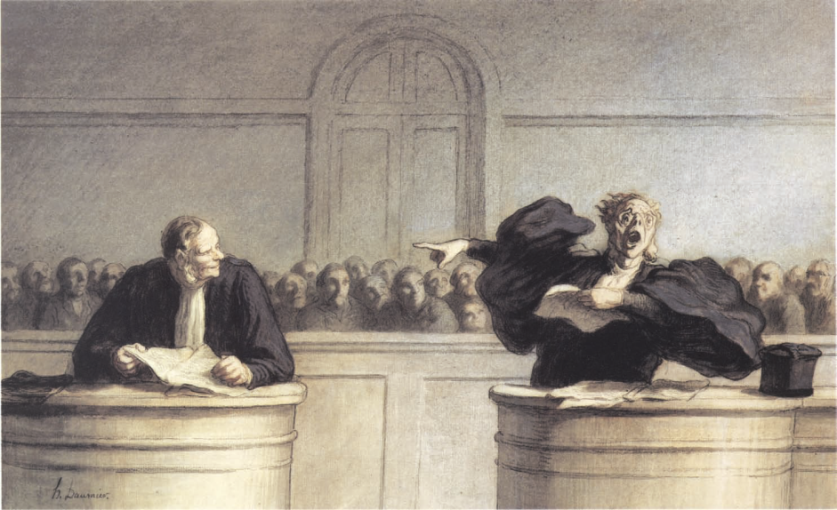

• Explains how historical developments in law influence and even shape contemporary world
• Transnational history course covering American and European developments
• Explores the key components of the rule of law, including constitutionalism, civil and property rights, crime and punishment, international law, and others
• Introduces the critiques of Western law by Marx and other thinkers
• No previous background or an interest in a legal career are needed

