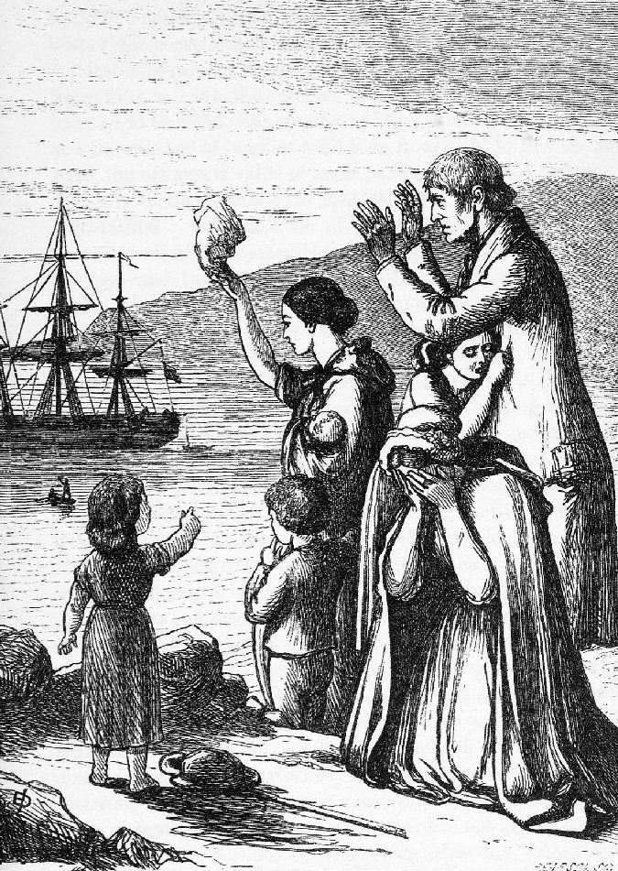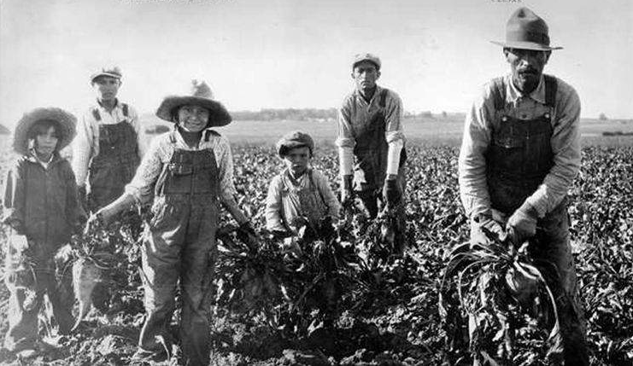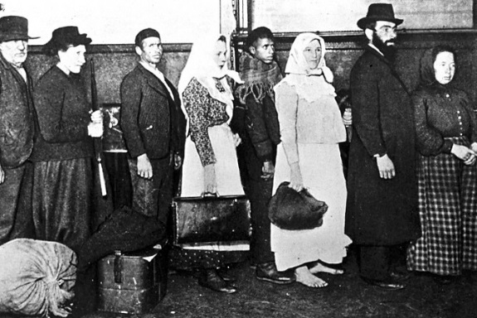
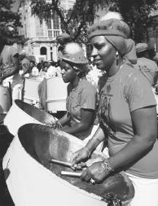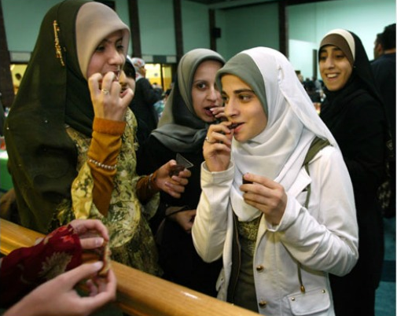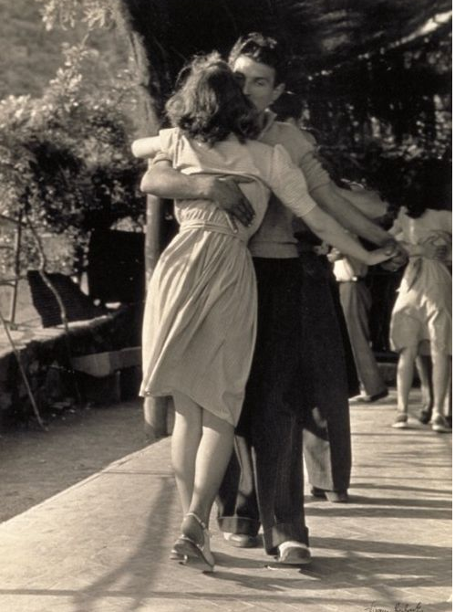

ST. JOHN’S DEPARTMENT OF HISTORY PRESENTS:

World History Theory and Practice Conference 2019:

Migrants and Refugees

Keynote Speaker: Dr. Hasia R. Diner (New York University and 2019 D’Angelo Chair in the Humanities):

“Food and the Immigrant Experience”

Date: April 23, 2019

Time: 8:30am-5:30pm

Location: DAC 416, Ballrooms A, B, C

