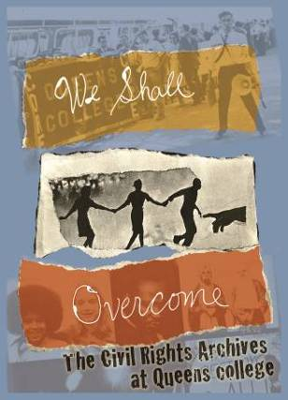 . 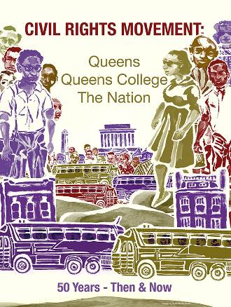 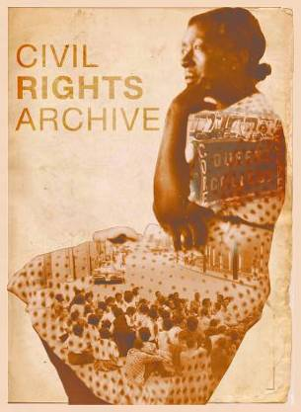

2013-2014: A Year of Civil Rights Movement 50th Anniversaries Commemoration Initiative
Queens College/CUNY Flushing, NY 11357

The 50th anniversary of Mississippi Freedom Summer 1964 will be recognized on campus during QC’s Spring 2014 Semester. It was one moment in a still ongoing struggle, but it had special connections to Queens College. Campus events are scheduled. This is a preliminary announcement and request to start planning to participate.
We hope you can:
a) Integrate aspects of its story into your Spring Semester course work;
b) Bring and/or assign students to attend related campus events;
c) Sponsor additional activities of your own that are related to your department;
d) Not just commemorate an event from fifty years ago, but show the leadership role that young people played in the Movement and its connections to the issues of today.

A number of QC students back in 1964 joined the summer project that came to be called “Freedom Summer” and travelled south to support the voting rights campaign and struggles against discrimination by local Mississippi civil rights groups. Some came back, some sadly did not. The Rosenthal Library Clock Tower commemorates that effort – and the loss of three young activists who were part of it.

There will be two specific and special events about Freedom Summer that we hope you can actively support:
1. The February 23rd and 24th performances of a play called “Freedom High” – written by playwright Adam Kraar, produced and directed by Prof. Susan Einhorn, acted using current QC students and alumni – is set at one of orientation sessions as the volunteers are being prepared to go to Mississippi and the “disappearance” of Goodman, Chaney, and Schwerner is dramatically announced. The volunteers and local activists have to deal with strong feelings and complex choices. The performances are co-sponsored by CERRU and Jewish Studies. A panel discussion will follow.
2. On March 13th, QC will be hosting a preview performance and talk by award-winning documentarian Stanley Nelson who just completed a new PBS film -- “Freedom Summer” – which will be aired on TV in June. (Nelson made the powerful documentary a few years ago about the Freedom Riders.)
Two preliminary notes: A) Experiences last semester with several events showed that faculty integration of materials and/or assignment of attendance made a significant difference to the success of the event, so we are really counting on you; B) Black History Month’s calendar will be filled with a number of other civil-rights related events. We will share that info and about April events with you soon.
In December and January of 1964, SNCC and other civil rights groups made the decision to have a Summer Project in Mississippi that would include voting rights campaigns, freedom schools, community centers, and other related efforts. In a matter of a very few short months, they had to: a) recruit, select and train 1,000 volunteers (students, ministers, lawyers, doctors and nurses, musicians, actors, etc.); b) organize support in the North to turn the political and media spotlight on the state of Mississippi and give material and financial support to those working in the state; c) find local homes, churches, and other places where the volunteers could eat, sleep, and work; d) devise communication and security systems for this ambitious project. The activists who organized and led all of this, it is critical to remember and emphasize with our classes, were in their late-teens and early-20’s! Quite a lesson and example for our students, in itself.
We will send you dates, times and locations of events soon.
PS -- If you and/or your department want to initiate and sponsor another event, invite a speaker to a class or discuss recommendations for readings, videos, music, etc., or help co-sponsor one of the events mentioned above, contact Mark Levy at mlevy697@earthlink.net

*** (Art above by QC design instructor Ryan Smith and two of his students.)

