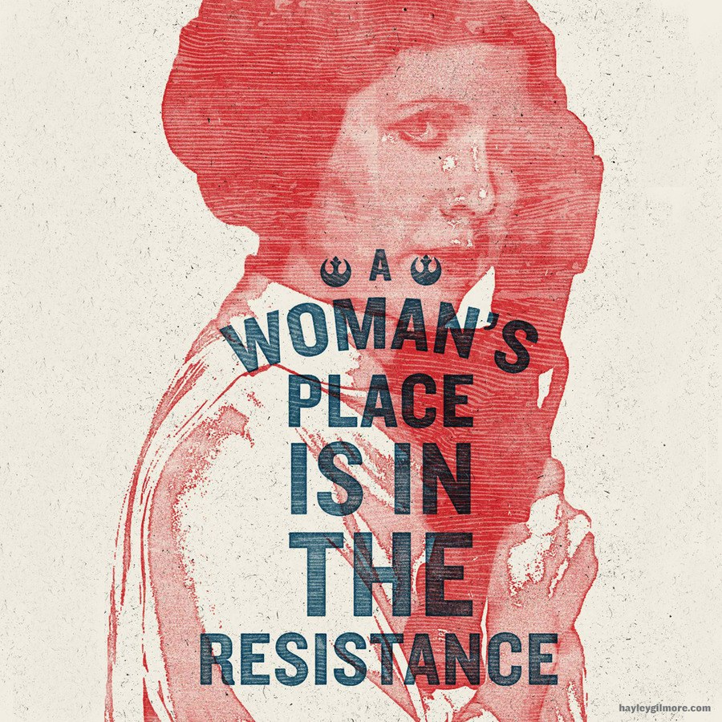  2019–20 ENGLISH HONORS SENIOR SEMINAR  (English 399W)  Prof. Caroline K. Hong  2 sections: TUE 1:40–4:30pm or WED 4:40–7:20pm  For more info about the English Honors Program, visit http://english.qc.cuny.edu/undergraduate/honors-program/. To apply for the English Honors Senior Seminar, contact Prof. Natalie Léger at nleger@qc.cuny.edu. | THE POWER OF THE POPULAR  (or, All Our Faves Are Problematic)  “popular culture is where the pedagogy is, it’s where the learning is.” —bell hooks  Stuart Hall says of popular culture, “It is an arena that is profoundly mythic. It is a theater of popular desires, a theater of popular fantasies. It is where we discover and play with the identifications of ourselves, where we are imagined, where we are represented, not only to the audiences out there who do not get the message, but to ourselves for the first time.” There’s no denying the power and potential of popular culture. That said, pop culture’s functions, meanings, and effects are never straightforward or static. As Robert G. Lee notes, pop culture is “always contested terrain.” It is a site of struggle and contradiction, of ambiguity and ambivalence, that functions as a “screen” onto which social and cultural anxieties and desires are projected and played out, where individual and collective identities are deconstructed and remade.  In next year’s English Honors Seminar, we will explore the problems and pleasures of pop culture and theorize the idea of the popular, broadly conceived. We will examine a variety of popular literature and pop-cultural productions that imagine and enact the popular in interesting and inventive ways, within the specific contexts of their production and consumption. As we study how pop culture has always shaped our understandings of our subjectivities, our communities, our nations, and our world, we will necessarily attend to the complicated relationship between the popular and the political, whether it manifests as propaganda and soft power on the one hand or in the service of dissent and resistance on the other. Along the way, we will also be engaging our own problematic fandoms and practicing the important work of critiquing the things we love.  We will cover a wide range of forms and genres, from Arthurian romance and broadside ballads to the Broadway musical Hamilton and internet memes. Texts will likely include readings by the Gawain Poet, William Shakespeare, Jane Austen, Edgar Allan Poe, Harriet Beecher Stowe, James Baldwin, Toni Morrison, Louise Erdrich, Ruth Ozeki, Gene Luen Yang, Chimamanda Ngozi Adichie, N. K. Jemisin, Rupi Kaur, Gabby Rivera, and QC’s own Briallen Hopper, as well as films such as Bamboozled and Crazy Rich Asians. We will also read diverse approaches to the popular from cultural studies, feminist and queer theories, critical ethnic studies, and postcolonial studies, including theory and criticism by Raymond Williams, Stuart Hall, Judith Butler, Eve Kosofsky Sedgwick, Laura Mulvey, Janice Radway, Lauren Berlant, Jack Halberstam, bell hooks, Hortense Spillers, Gayatri Chakravorty Spivak, Gayatri Gopinath, and Sianne Ngai.

