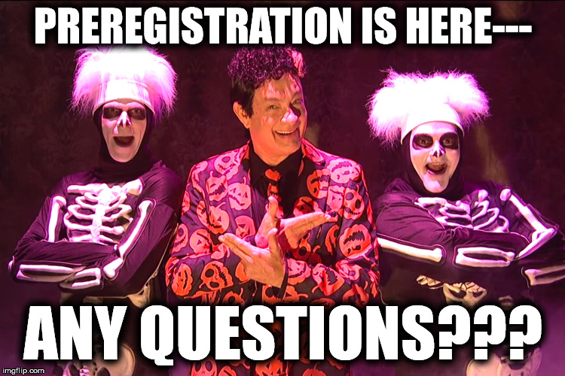

Preregistration for undergraduate English majors and minors will take place in Klapper Hall Room 601 on Monday Oct 29, 12-3pm; Tuesday Oct 30, 11am-3pm; and Wednesday Oct 31, 12-2pm. A full course list is now available for review on CUNYFirst, and detailed course descriptions are posted on the bulletin board on the sixth floor of Klapper Hall.

Students are also invited to submit requests for preregistration via email during these dates only (sent to english@qc.cuny.edu). Emailed requests MUST include the following:
- Student's full name
- Student's CUNYFirst ID number
- The list of requested courses (up to three for the Spring semester, and one for the Winter session)
- The four or five digit course code of each course
(You may use the Registration Slip below for email requests)
Email requests received before the preregistration period begins, or that don't contain all the required information, will not be processed.

MA students wishing to preregister for graduate courses should contact Prof. Orchard, the Director of Graduate Studies (william.orchard@qc.cuny.edu). Students wishing to preregister for MFA courses should contact Nicole Cooley, the Director of the MFA program (nicole.cooley@qc.cuny.edu).
If you have any questions, please don't hesitate to contact: sian.silyn.roberts@qc.cuny.edu

REGISTRATION SLIPS FOR EMAIL REQUESTS
PREREGISTRATION FOR WINTER

Name: _____________________________

Student ID#: ______________________ (8 digit)

Please indicate 1 course for which you would like to register for the Winter 2019 semester.
Course Number: 3 digit | Class Number

PREREGISTRATION FOR SPRING

Please indicate up to 3 courses for which you would like to register for
the Spring 2019 semester.

Course Number: 3 digit | Class Number

