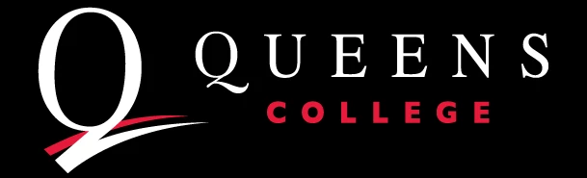

Fall 2023 |Department of Sociology
Department Internal Seminar Series

Note: Unless otherwise stated, all seminar sessions will be hosted in person in the sociology department lounge from 12:15 pm to 1:30 pm ET on Wednesdays.

October 23rd, 2023 (Monday)
Pyong Gap Min
“Technological Advances and Immigrants' Strong Cultural Linkages to Homeland: A New Form of Adaptation to Host Society” (Presentation)

November 15th, 2023
Dana Weinberg
“The Antisemitic Language Game: Dog Whistles and Conspiracy Narratives on Social Media.” (Presentation)

November 29th, 2023
A.K.M. Skarpelis
“When Whiteness Fails” (R&R workshop)

December 6th, 2023
Peter Dewey Ore
Book proposal workshop.

