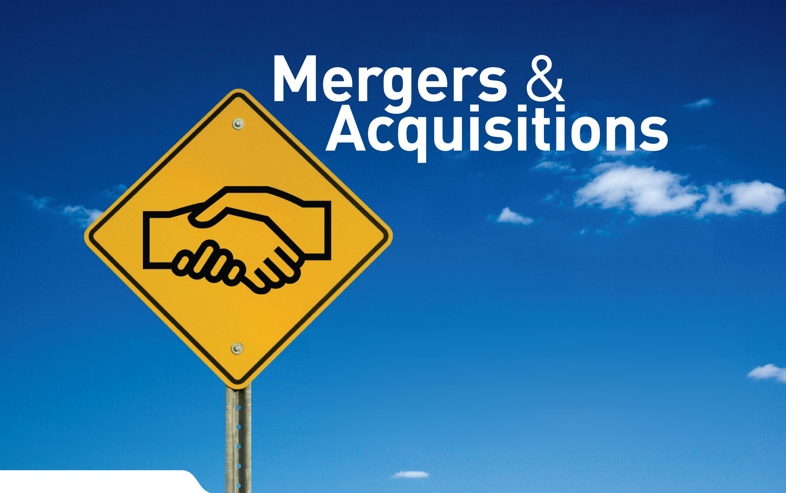
An Ascend Queens College Production


Understanding Transaction Services
With Kevin Gay, PwC TS Associate

- Join us for a session about Transaction Services at a Big 4 firm.
- Learn about their advisory roles in the exciting M&A environment and the opportunities that may exist for you!
Tuesday, April 21
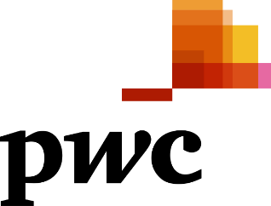
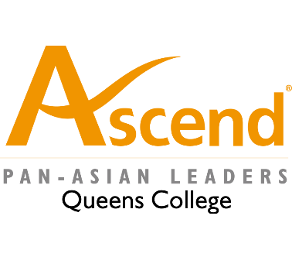
6:30-8:00PM
CAMPBELL DOME

RSVP @ transactionservicespwc.eventbrite.com

