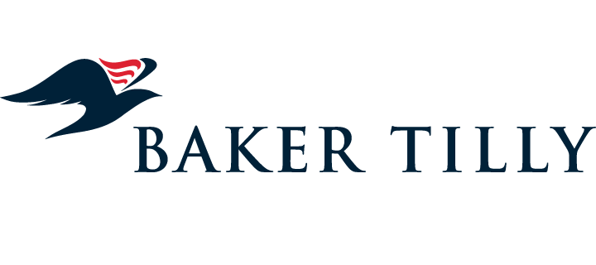

Visit the Manhattan Office of

Explore career opportunities, network with Queens College Alumni, and learn more about why Baker Tilly is great place for a career.
Baker Tilly Virchow Krause, LLP (Baker Tilly) is a nationally recognized, full-service accounting and advisory firm whose specialized professionals connect with clients and their businesses through refreshing candor and clear industry insight. With approximately 2,800 employees across the United States, Baker Tilly is ranked as one of the 15 largest accounting and advisory firms in the country. Headquartered in Chicago, Baker Tilly is an independent member of Baker Tilly International, a worldwide network of independent accounting and business advisory firms in 147 territories, with 33,600 professionals. The combined worldwide revenue of independent member firms is $3.4 billion.
September 28th | 9-11am.
Sophomore, Junior, Senior | Graduate and Undergraduate Accounting students
Limited space
Application Deadline: September 14th
Apply at: http://tinyurl.com/y9vs7bqv
Accepted students need to attend a one hour briefing on September 26th during free hour



