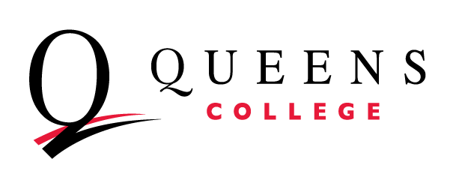
The Office of Career Development and Internships
invites eligible students to participate in our
2017-2018 “Accounting Recruitment & Referral Program”

Students interested in pursuing a career as a
Certified Public Accountant
should submit their resume for review immediately!

Degree Requirements: Undergraduate Degree with 150 Credits (not 120 Credits)
Master’s Degree
3.0 Minimum GPA

Dates of Graduation: September 2017
December 2017
May 2018

Resume Deadline: September 19th
Drop off your resume asap for review to the Career Office or email it as a Word Document to qc_career@qc.cuny.edu

- Employer interviews begin on campus Thursday September 28th
- The Fall Semester is the only season these firms are recruiting for full-time positions post-graduation-not the Spring semester.
Don’t miss out on this great opportunity!
We look forward to kicking off the new season with our QC Students!
For additional information or questions please contact
The Office of Career Development and Internships:
Virginia Frese Hall #213
(718) 997-4465
www.qc.cuny.edu/career

